CPTS 411 HW1 REPORT

**Experimental platform:** I am running the code and test on my Win7 x64 desktop on SSD. The CPU is Xeon E1230v2, 4 cores 8 threads, Clock speed 3.30GHz, 8MB SmartCache, 14GB DDR3 RAM installed.

**Performance evaluation:**

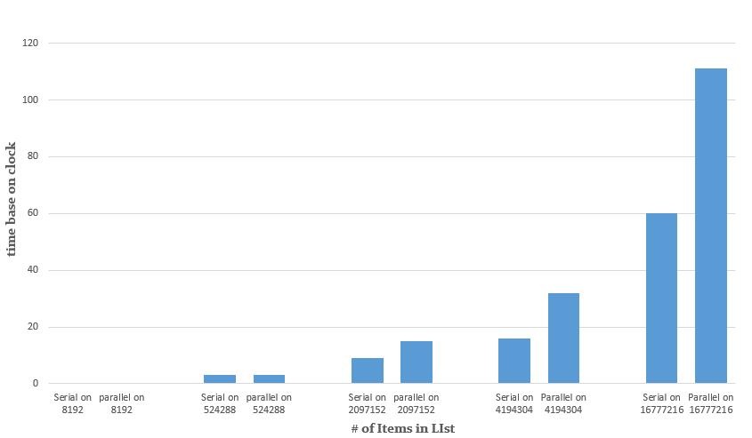

|  |  |  |
| --- | --- | --- |
| # in list | Serial code clock time | Parallel code clock time |
| 8192 | 0 | 0 |
| 524288 | 3(±1) | 3(±1) |
| 2097152 | 9(±1) | 15(±1) |
| 4194304 | 16(±1) | 32(±3) |
| 16777216 | 60(±1) | 111(±5) |

For small numbers in the list to sum, the time take for serial code and parallel code are almost same. But as the size of List increase, the “Parallel code” time started to take nearly as twice as the serial code takes. There is some time variance for parallel as the # in list get larger, but still remains single digits clock speed in my test. Serial code clock time variances are very low, I think just the program running in background affecting them.

I was expecting the Parallel code will take longer time than the serial code, since it is not the real Parallel, just simulated by serial code. It will have extra things in this “Parallel” code drag it’s speed down. but I wasn’t expecting this parallel code end up nearly twice slower than serial code. That may because the implementation of simulate algorithm of mine is not well enough that takes more time.